**Spiral Model**

1. **Introduction**

* It is a risk-driven software process framework (the spiral model) was proposed by Boehm (1988). Here, the software process is represented as a spiral, rather than a sequence of activities with some backtracking from one activity to another.
* The spiral model is an evolutionary software process model that combines the idea of iterative development with the systematic, controlled aspects of the waterfall model. This Spiral model is a combination of iterative development process model and sequential linear development model i.e. the waterfall model with a very high emphasis on risk analysis. It allows incremental releases of the product or incremental refinement through each iteration around the spiral.
* It provides the potential for rapid development of increasingly more complete versions of the software.
* **Spiral model** is one of the most important Software Development Life Cycle models, which provides support for **Risk Handling**. In its diagrammatic representation, it looks like a spiral with many loops. The exact number of loops of the spiral is unknown and can vary from project to project.
* Each loop in the spiral represents a phase of the software process. Thus, the innermost loop might be concerned with system feasibility, the next loop with requirements definition, the next loop with system design, and so on.

1. **Diagrams**

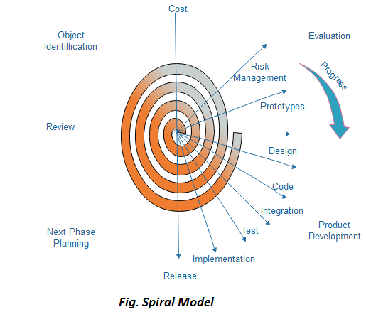

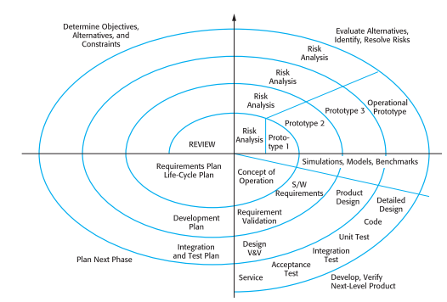

1. **Spiral Model – Design and Purpose**

The spiral model has four phases. A software project repeatedly passes through these phases in iterations called Spirals.

1. **Identification and Objectives**

* This phase starts with gathering the business requirements in the baseline spiral. In the subsequent spirals as the product matures, identification of system requirements, subsystem requirements and unit requirements are all done in this phase. Requirements are gathered from the customers and the objectives are identified, elaborated and analyzed at the start of every phase.
* This phase also includes understanding the system requirements by continuous communication between the customer and the system analyst. At the end of the spiral, the product is deployed in the identified market.
* Each cycle in the spiral starts with the identification of purpose for that cycle, the various alternatives that are possible for achieving the targets, and the constraints that exists.
* A detailed management plan is drawn up. Project risks are identified. Alternative strategies, depending on these risks, may be planned.

1. **Risk Analysis and Reduction**

* During the second quadrant all the possible solutions are evaluated alternatives based on the goals and constraints to select the best possible solution. Then the risks associated with that solution is identified and the risks are resolved using the best possible strategy. At the end of this quadrant, Prototype is built for the best possible solution.
* Risk Analysis includes identifying, estimating and monitoring the technical feasibility and management risks, such as schedule slippage and cost overrun. After testing the build, at the end of first iteration, the customer evaluates the software and provides feedback.
* Based on the customer evaluation, the software development process enters the next iteration and subsequently follows the linear approach to implement the feedback suggested by the customer. The process of iterations along the spiral continues throughout the life of the software.

1. **Development and Validation**

* The next phase is to develop strategies that resolve uncertainties and risks. This process may include activities such as benchmarking, simulation, and prototyping.
* **Prototyping Model** also support risk handling, but the risks must be identified completely before the start of the development work of the project. But in real life project risk may occur after the development work starts, in that case, we cannot use Prototyping Model.
* In each phase of the Spiral Model, the features of the product dated and analyzed and the risks at that point of time are identified and are resolved through prototyping. Thus, this model is much more flexible compared to other SDLC models.
* Then in the subsequent spirals with higher clarity on requirements and design details a working model of the software called build is produced with a version number. These builds are sent to the customer for feedback.

**Design**

* The Design phase starts with the conceptual design in the baseline spiral and involves architectural design, logical design of modules, physical product design and the final design in the subsequent spirals.

**Development and Testing**

* The Product is Developed and tested in this phase.

1. **Planning and Implementation**

* Finally, the next step is planned. The project is reviewed, and a choice made whether to continue with a further period of the spiral. If it is determined to keep, plans are drawn up for the next step of the project.
* The product is Deployed and Customer Feedback is taken into consideration.
* The Maintenance of the product and further enhancement can also be done in this phase.

**Purpose**

## When to use Spiral Model?

* When deliverance is required to be frequent.
* When the project is large and high budget where costs and risk evaluation is important.
* When requirements are unclear and complex
* When changes may require at any time
* When there is a budget constraint and risk evaluation is important.
* For medium to high-risk projects.
* Long-term project commitment because of potential changes to economic priorities as the requirements change with time.
* Customer is not sure of their requirements which is usually the case.
* Requirements are complex and need evaluation to get clarity.
* New product line which should be released in phases to get enough customer feedback.
* Significant changes are expected in the product during the development cycle.

1. **Advantages**

The advantages of the Spiral SDLC Model are as follows −

* Change requests in the Requirements at later phase can be incorporated accurately by using this model.
* Cost Estimation becomes easy.
* Allows extensive use of prototypes.
* Requirements can be captured more accurately.
* Users see the system early.
* Development can be divided into smaller parts and the risky parts can be developed earlier which helps in better risk management.
* Customer can see the development of the product at the early phase of the software development and thus, they habituated with the system by using it before completion of the total product

1. **Disadvantages**

The disadvantages of the Spiral SDLC Model are as follows −

* Management is more complex.
* End of the project may not be known early.
* Not suitable for small or low risk projects as it could be expensive for small projects.
* Process is complex than other SDLC models.
* Spiral may go on indefinitely.
* The successful completion of the project is highly much dependent on Risk Analysis which requires Specific expertise.
* Large number of intermediate stages requires excessive documentation.

1. **Realtime Examples**

* One of the most interesting things about the SDLC Spiral model is that Microsoft used it to develop early versions of Windows. The Gantt chart software was made using the model as well. Thus, there are no surprise here — big, high risk projects, which are also aimed at a wide audience, choose Spiral Model.
* Game development is another industry that uses the Spiral model. As we discussed above, the model allows for creating prototyping carefully and quickly. As the gaming industry heavily relies on early game versions, Spiral becomes a solid option. With the model, game development companies can get feedback from their customers really fast and develop a playable that would evolve into equally playable games faster.

**References**

[1]Ian Sommerville “Software Engineering (Ninth Edition)”. [Pages 48-50].

[2] <https://www.javatpoint.com/software-engineering-spiral-model>

[3] <https://www.geeksforgeeks.org/software-engineering-spiral-model>

[4] <https://en.wikipedia.org/wiki/Spiral_model>